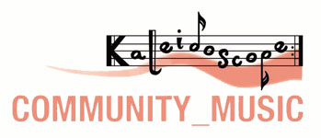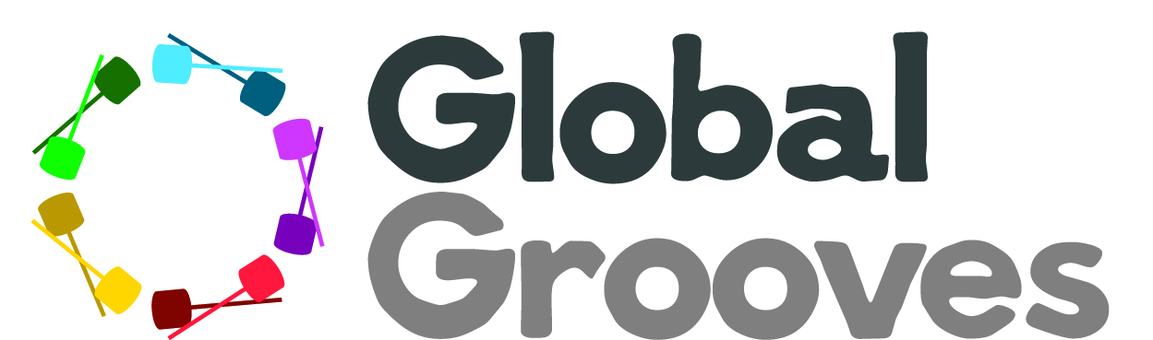

Bloco Ketu: A percussion workshop with Leon Patel. Hosted by Kaleidoscope Community Music in association with Global Grooves

Booking Form

Thanks for your interest in this exciting workshop! Please complete this booking form and return by email to: info@kcm-music-derby.org.uk or kcmtickets@gmail.com

You will then receive payment details. Please note, your place will not be secured until both a booking form and payment has been received. The early bird is now over. The final deadline for bookings and payments is now Sat 28th May.

Name:

Address:

Postcode:

Email address:

Phone number:

“I do\do not give permission for my name and contact details to be added to Global Groove’s mailing list.” (Please delete as appropriate)

“I do\do not give permission for my name and contact details to be added to Kaleidoscope Community Music’s mailing list.” (Please delete as appropriate)

How long have you been playing percussion\carnival percussion?

Which band do you currently play with (if any):

Please tell us about your percussion or music experience to date, instruments played and ability level (beginner\intermediate\advanced):

The instruments taught for this workshop will be: Bells, Caixa, Repinique, Timbau, Surdo. Please bring your own instruments where possible. Some can be provided on reservation but may be limited.

Please tell us your 1st and 2nd choice instrument below and whether or not you can bring your own. We can’t guarantee you’ll be able to play your first choice instrument, dependent on number and balance of instruments required on the day:

1st choice instrument: I can\can’t bring my own
2nd choice instrument: I can\can’t bring my own

Payment Options

Payment can be made by either PayPal (with an additional booking fee of £1.50 per ticket) or by bank transfer (no additional charge).

Please let us know which you prefer:

